Gerund Phrase Subject

✅ What is Gerund Phrase Subject
# Source: AI Source: Provided by: [Data Path: Persons Table -> ID Column: 1, Name_En Column: Motasem Essam] -> From: [Chatgpt (GPT-4-turbo)] on [8/4/2025]
A gerund phrase subject is a phrase that begins with a gerund (a verb ending in -ing) and includes its object and/or modifiers, all functioning together as the subject of a sentence.
It answers "What is doing the action?" and acts as a noun.

🔹 Structure:
# Source: AI Source: Provided by: [Data Path: Persons Table -> ID Column: 1, Name_En Column: Motasem Essam] -> From: [Chatgpt (GPT-4-turbo)] on [8/4/2025]
[Gerund] + [object/modifiers/complements]

🔹 Key Features:
# Source: AI Source: Provided by: [Data Path: Persons Table -> ID Column: 1, Name_En Column: Motasem Essam] -> From: [Chatgpt (GPT-4-turbo)] on [8/4/2025]
- The whole phrase acts as a single subject.
- Always begins with a gerund (e.g., reading, swimming, writing).
- The verb in the sentence agrees with the gerund phrase (usually singular).

🔹 Examples of Gerund Phrase Subjects:
# Source: AI Source: Provided by: [Data Path: Persons Table -> ID Column: 1, Name_En Column: Motasem Essam] -> From: [Chatgpt (GPT-4-turbo)] on [8/4/2025]
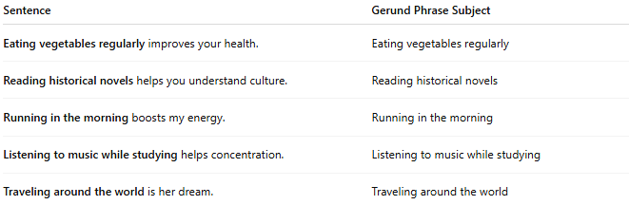
Sentence | Gerund Phrase Subject
Eating vegetables regularly improves your health. | Eating vegetables regularly
Reading historical novels helps you understand culture. | Reading historical novels
Running in the morning boosts my energy. | Running in the morning
Listening to music while studying helps concentration. | Listening to music while studying
Traveling around the world is her dream. | Traveling around the world

🔍 Comparison:
# Source: AI Source: Provided by: [Data Path: Persons Table -> ID Column: 1, Name_En Column: Motasem Essam] -> From: [Chatgpt (GPT-4-turbo)] on [8/4/2025]
- Gerund subject = just the -ing word
Swimming is fun.
- Gerund phrase subject = -ing word + extra elements
Swimming in the ocean is fun.

